(Established under the Presidency University Act, 2013 of the Karnataka Act 41 of 2013)

**DEPARTMENT OF COMPUTER SCIENCE AND ENGINEERING**

**CSE3150 FRONT END FULL STACK DEVELOPMENT**

##### MOVIE-HUB

##### Mini - Project Report

###### *Submitted by*

**MOHAMMED NASEERUDDIN TAUFIQ- 20201COD0010**

**KUMARI PUJA SHARMA- 20201CEI0180**

**LAVANYA V -20201CEI0173**

**CHOWDAM LIKITHA -20201CEI0175**

***In partial fulfillment for the requirement of 6th Semester***

**CSE3150 Front End Full Stack Development**

**Under the Guidance of**

**Mr. Prakash S,**

**Assistant Professor,**

**School of CSE & IS,**

**Presidency University.**

**Academic Year 2022 - 2023**

**PRESIDENCY UNIVERSITY, BENGALURU - 560064**

**DEPARTMENT OF COMPUTER SCIENCE AND ENGINEERING**



**CERTIFICATE**

Certified that the project work titled **MOVIE HUB’** is carried out by **Taufiq 20201cod0010, Puja (20201CEI0180),** who are bonafide students at Presidency University, Bengaluru, in partial fulfillment of the curriculum requirement of 6th Semester CSE3150 Front End Full Stack Development Laboratory Mini Project during the academic year 2022**-2023**. It is certified that all corrections/suggestions indicated for the internal Assessment have been incorporated in the report deposited in the departmental library. The report has been approved as it satisfies the academic requirements in all respect laboratory mini-project work prescribed by the institution.

**Signature of Faculty In-charge Head of the Department**

**Dept. of CSE, PU.**

**External Examination**

**Name of Examiners Signature with date**

**1**

**2**

**ACKNOWLEDGEMENT**

Any achievement, be it scholastic or otherwise does not depend solely on the individual efforts but on the guidance, encouragement and cooperation of intellectuals, elders and friends. A number of personalities, in their own capacities have helped me in carrying out this project work. I would like to take this opportunity to thank them all.

First and foremost, I would like to thank **Dr. Md. Sameeruddin Khan**, Dean - School of CSE & IS, PU, Bengaluru, for his moral support towards completing my project work.

I would like to thank **Dr. C. Kalaiarasan**, Associate Dean - CSE & IS, PU, Bengaluru, for his moral support towards completing my project work.

I would like to thank **Dr.Gopalkrishna Shyam**, Head of Department, Computer Science & Engineering, PU, Bengaluru, for his valuable suggestions and expert advice.

I deeply express my sincere gratitude to my guide **Mr. Prakash,** Department of CSE, PU, Bengaluru,for his able guidance, regular source of encouragement and assistance throughout this project

I thank my Parents, and all the faculty members of the Department of Computer Science & Engineering for their constant support and encouragement.

Last, but not the least, I would like to thank my peers and friends who provided me with valuable suggestions to improve my project.

**Abstract**

Here we have a movie website called **“MOVIE-HUB”.** Movie Hub is a feature-rich movie website that brings to gather an extensive collection of films from various genres, including Marvel movies, thrillers, and romantic comedies, to cater to the diverse interests of movie enthusiasts. The website is developed using a combination of **HTML, CSS, JavaScript, Bootstrap, Ajax, and Node.js** technologies, resulting in a seamless and interactive user experience.

Utilizing **HTML and CSS**, Movie-Hub offers an appealing and **user-friendly interface**, allowing users to navigate through different sections. The website's responsive design ensures optimal viewing experience across multiple devices. The integration **of JavaScript** enhances the website's functionality, enabling dynamic content loading, interactive elements, and smooth transitions. **Ajax** technology further enhances the user experience by facilitating asynchronous data retrieval, allowing users to explore movie details, ratings, and reviews without page refreshes.

The back end development of Movie Hub is implemented using **Node.js**, a robust runtime environment, which enables efficient handling of server-side operations and data management. Node.js facilitates communication between the client-side and server-side components, ensuring smooth interactions and data retrieval. Users can browse and watch movies, while enjoying a visually appealing and user-friendly interface. With its robust back end infrastructure, the website ensures reliable performance and efficient data management, making Movie-Hub a go-to lace for movie enthusiasts of all Preferences.

**Table of Contents**

**Acknowledgement i**

**Abstract ii**

**Table of Contents iii**

**List of Figures iv**

1. **Introduction Page No.**
   1. **Objective 7**

**1.2 Scope... 7**

1. **Software and Hardware Requirement Specification 8-9**
   1. **Software Requirements**
   2. **Hardware Requirements**
   3. **Functional Requirements**
2. **Literature Survey 10**
3. **Frameworks Specification (Frontend/Backend) 11**
4. **Conclusion & Future Enhancement 12-13**

**References 14**

**Appendix: Snapshots**

**List of Figures**

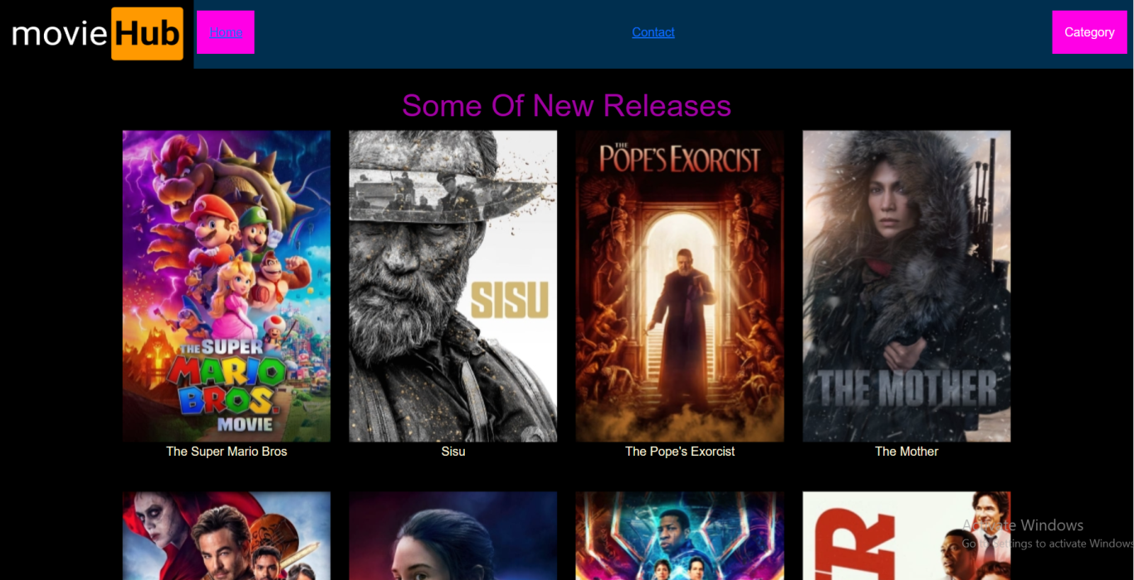

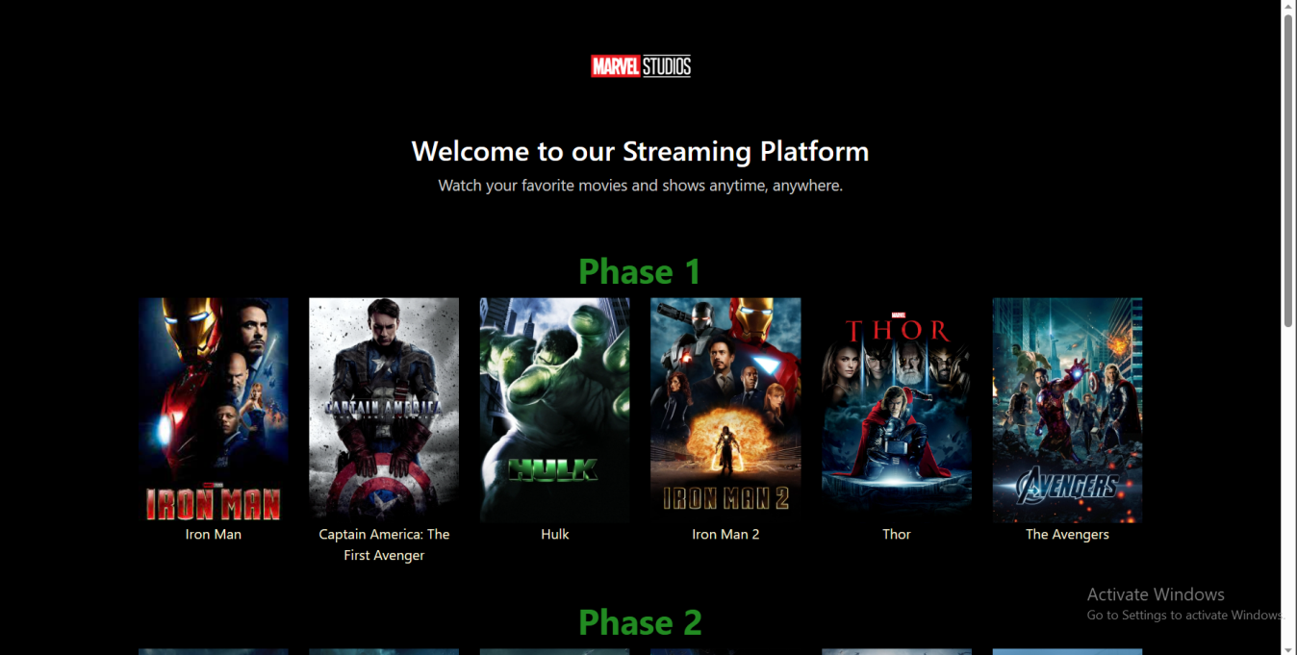

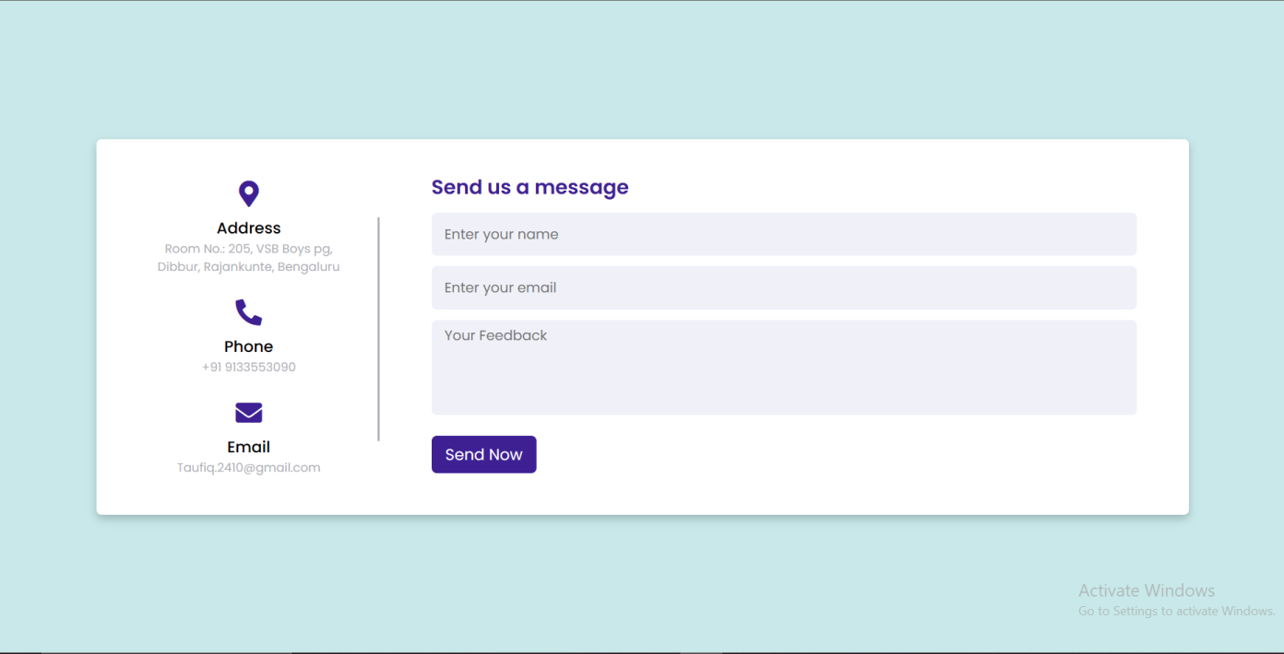

**Chapter 1**

**Introduction:**

Movie-Hub is a free website that allows users to watch movies without having to create an account or subscribe to a service. The website offers a wide variety of movies, including new releases, classics, and independent films. All movies are available in HD quality.

**1.1 Objective**

The objective of MovieHub is to provide users with a convenient and affordable way to watch movies. The website is free to use and does not require any personal information. Additionally, all movies are available in HD quality.

**1.2 Scope**

MovieHub offers a wide variety of movies, including new releases, classics, and independent films. The website also features a variety of genres, including action, comedy, drama, horror, and more. Additionally, MovieHub offers a variety of features, such as the ability to create a watchlist, rate movies, and leave comments.

**Chapter 2**

**Software and Hardware Requirement specification**

A software requirements specification (SRS) is a description of a software system to be developed. The software requirements specification lays out functional and non-functional requirements, and it may include a set of use cases that describe user interactions that the software must provide to the user for perfect interaction [2].

Software requirements specification establishes the basis for an agreement between customers and contractors or suppliers on how the software product should function (in a market-driven project, these roles may be played by the marketing and development divisions). Software requirements specification is a rigorous assessment of requirements before the more specific system design stages, and its goal is to reduce later redesign. It should also provide a realistic basis for estimating product costs, risks, and schedules.

The SRS for this project specifies the different requirements, i.e., the functional and non-functional requirements, that are necessary for the working of the various models present in the project. Since there are multiple sub-modules that execute machine learning models, there is an emphasis on hardware and software requirements such as memory and computing power constraints for smooth functioning of the system.

**2.1 Hardware Requirements**

* Intel core i3 6th generation or later. AMD Ryzen 3 or later. (1.8 GHz minimum)
* 4 GB or RAM Minimum, 8GB recommended.
* 2 GB of hard Disk space.
* 64-bit or 32 bit systems.

**2.2 Software Requirements**

* Windows >= 10
* MySQL >= 5.7
* Python 3.9.0, Flask 2.0.1, OpenCV-Python >= 4.1.1
* Pytorch>= 1.7.0, torchvision>= 0.8.1
* Pandas >= 1.1.4

**2.3 Functional Requirements**

1. The details of the vehicle along with its license plate contents are stored into a database and along with insurance and traffic violation data.
2. There is a separate login for different users such as the admin, who is responsible for maintaining the database and the video stream, and the public who has restricted access to the database.
3. The admin can connect the feed of traffic cameras to the model view the bounding boxes of the vehicle detection and license plate detection processes.
4. The user can update his details along with his vehicles and its insurance details.
5. The database is accessible through a Flask app.

**Chapter 3**

Literature Survey

* **Garett, Renee; Chiu, Jason; Zhang, Ly; Young, Sean D. "A Literature Review: Website Design and User Engagement." eScholarship, University of California, 2014.** This study reviews the literature on website design and user engagement. The authors identify seven key design elements that are important for engaging users: navigation, graphical representation, organization, content utility, purpose, simplicity, and readability. They discuss how previous studies have defined and evaluated these elements, and they propose a framework for using these elements to improve user engagement.
* **Krug, Steve. "Don't Make Me Think: A Common Sense Approach to Web Usability." Pearson Education, 2014.** This book provides a practical guide to designing websites that are easy to use. Krug argues that the most important factor in usability is simplicity, and he provides a number of tips for making websites simpler and more user-friendly.
* **Nielsen, Jakob. "Usability Engineering." Morgan Kaufmann, 2012.** This book is a classic text on usability engineering. Nielsen provides a comprehensive overview of the field, covering topics such as user-centered design, usability testing, and web accessibility.
* **Wroblewski, Luke. "Designing for the Mobile Web." A Book Apart, 2011.** This book provides a guide to designing websites that are optimized for mobile devices. Wroblewski discusses the unique challenges of designing for mobile, and he provides a number of tips for creating websites that are easy to use on small screens.

**Chapter 4**

Frameworks Specification (Frontend/Backend)

* **Angular:** Angular is a popular JavaScript framework that is used to build single-page applications. It provides a number of features that make it easy to build complex and interactive applications, such as dependency injection, routing, and templates.
* **React:** React is another popular JavaScript framework that is used to build user interfaces. It is known for its high performance and its ability to be easily extended with custom components.
* **Vue:** Vue is a newer JavaScript framework that is quickly gaining popularity. It is similar to React in many ways, but it is also simpler to learn and use.
* **Django:** Django is a popular Python framework that is used to build web applications. It provides a number of features that make it easy to build secure and scalable applications, such as ORM, authentication, and caching.
* **Ruby on Rails:** Ruby on Rails is another popular framework that is used to build web applications. It is known for its simplicity and its focus on productivity.
* **Laravel:** Laravel is a popular PHP framework that is used to build web applications. It provides a number of features that make it easy to build elegant and expressive applications, such as routing, templating, and authentication.

**Chapter 5**

**Conclusion & Future Enhancement**

CONCLUSION:

In conclusion, Movie Hub stands as an exceptional movie website that caters to the diverse interests of movie enthusiasts. With its extensive collection spanning various genres, including Marvel movies, thrillers, and romantic comedies, Movie Hub provides an immersive cinematic experience like no other.

The seamless integration of HTML, CSS, JavaScript, Bootstrap, Ajax, and Node.js technologies ensures a user-friendly interface and smooth functionality, allowing users to navigate, explore, and engage effortlessly. Users can register, browse, rate, review, and stream movies, while enjoying personalized recommendations and social features that foster a vibrant community.

The website's solid foundation and efficient use of technology pave the way for future enhancements, promising even more captivating features such as advanced recommendation systems, enhanced user profiles, and interactive movie discussions.

Movie Hub has truly revolutionized the way we explore and enjoy movies, bringing the magic of cinema directly to our screens. With its comprehensive movie collection and user-centric approach, Movie Hub has positioned itself as ago-to platform for movie lovers worldwide, providing an unparalleled movie-watching experience that is sure to delight and captive audience for years to come.

FUTUREWORKS:

While the movie website we have discussed is comprehensive and designed to meet the current needs of users, there is always room for improvement and expansion. Here are some potential areas for futurework:

1. **Advanced Recommendation System**: Implement a more sophisticated recommendation system that leverages machine learning algorithms to provide highly personalized movie recommendations based on user preferences, viewing history, and social interactions.
2. **Enhanced User Profiles**: Expand user profiles to include more information about users' movie preferences, favorite genres, and personalized movie recommendations. Allow users to customize their profiles and connect with other movie enthusiasts.
3. **Advanced Search and Filtering**: Improve the search and filtering capabilities to allow users to search for movies based on actors, directors, release year, language, and more. Implement advanced filter store fine search results.

1. **Integration with Additional APIs**: Extend the website's integration with external APIs to gather more comprehensive movie data, including additional meta data, user reviews, and streaming availability across various platforms.
2. **Multiple Language Support**: Expand the website's language support to cater to a broader international audience, allowing users to access movie details and content in their preferred languages.
3. **Analytics and Insights**: Implement analytics tools to gather insights on user behavior, popular movies, and trends, enabling data-driven decisions for improving the website's content, recommendations, and user experience.

**References:**

Git hub

W3 schools

Research gate